Open Curves

Definition
# Source: AI Source: Provided by: [Data Path: Persons Table -> ID Column: 1, Name_En Column: Motasem Essam] -> From: [ChatGPT] on [7/25/2026]
An open curve is a curve in a plane that does not form a closed loop. It has two distinct endpoints and does not return to its starting point.
$$\boxed{\text{Open Curve}=\text{Continuous Curved Path with Two Distinct Endpoints}}$$
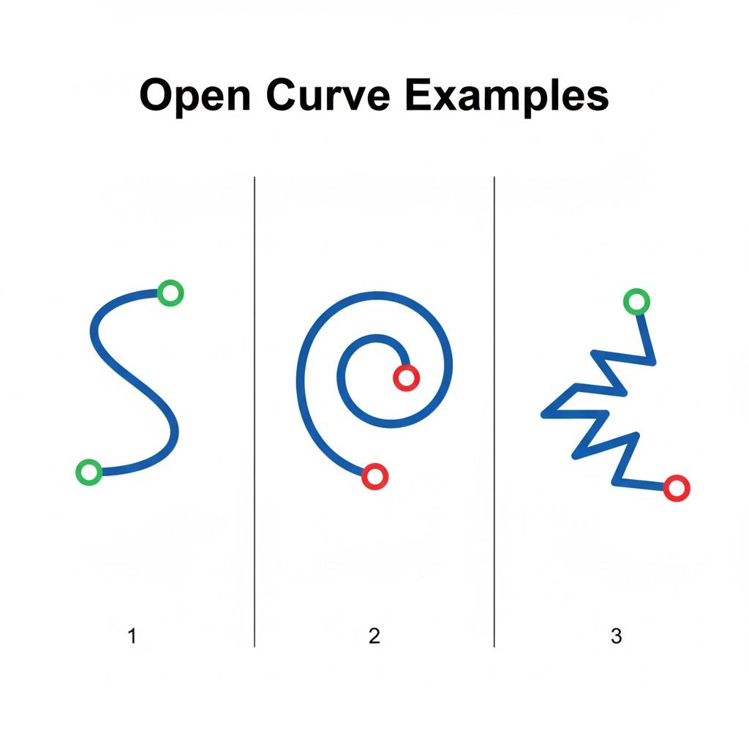
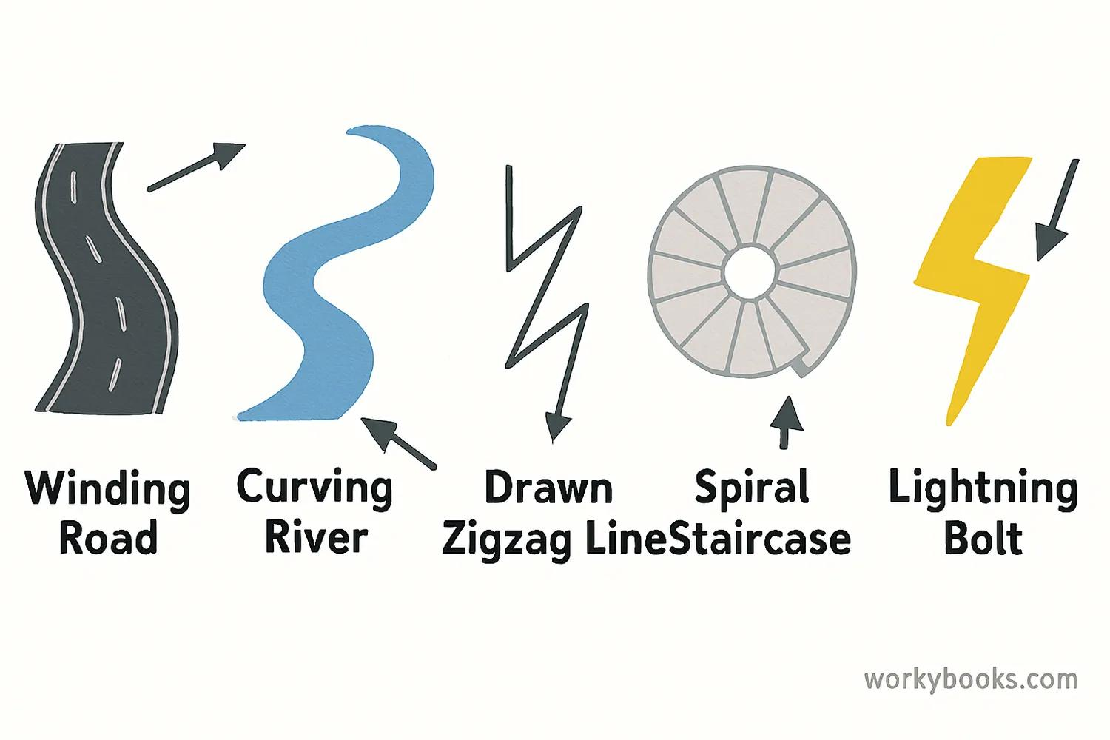
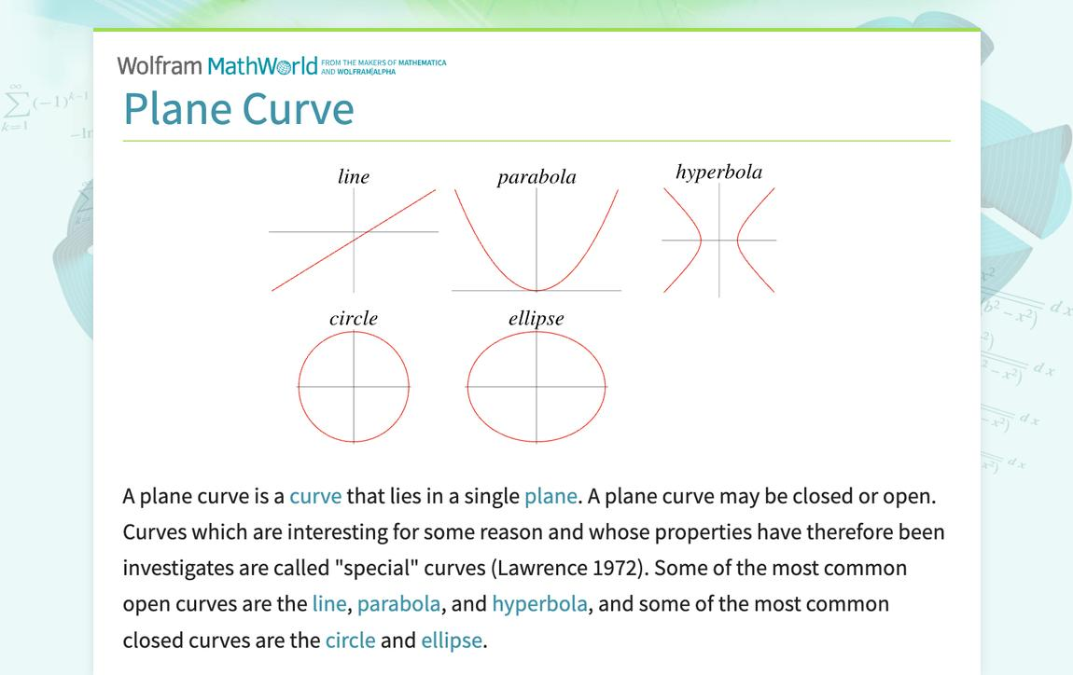
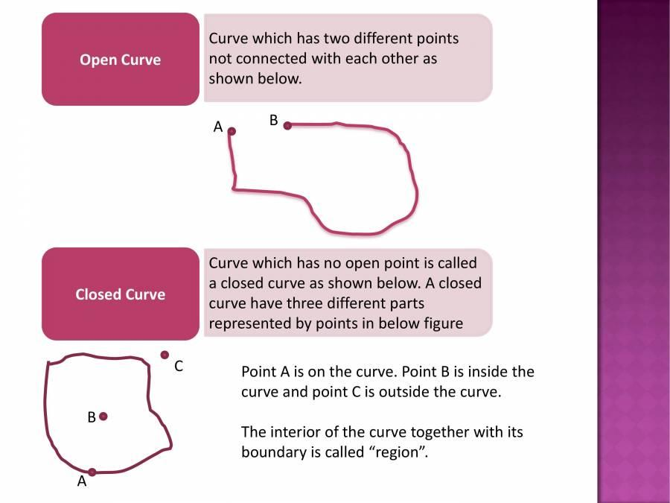

Types of Open Curves

1. Open Circular Arcs
# Source: AI Source: Provided by: [Data Path: Persons Table -> ID Column: 1, Name_En Column: Motasem Essam] -> From: [ChatGPT] on [7/25/2026]
An open circular arc is a portion of a circle between two endpoints.
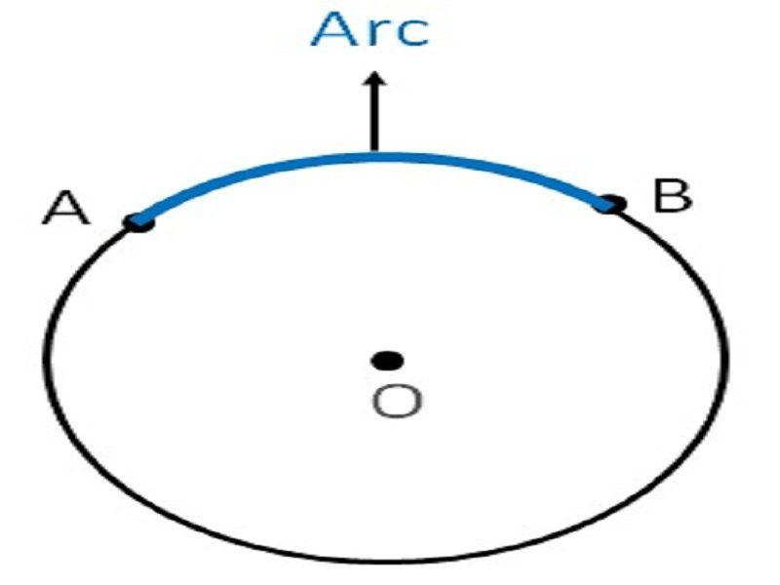
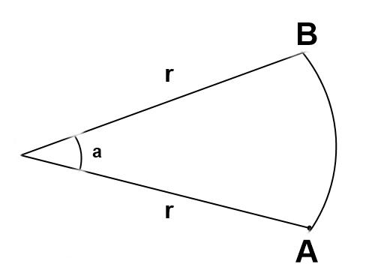
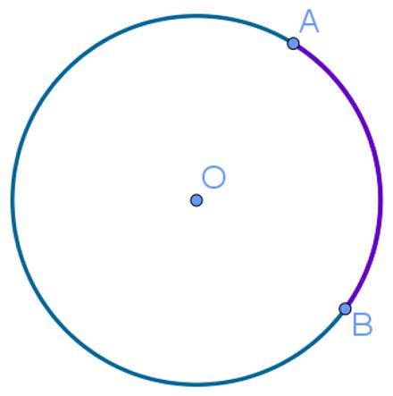
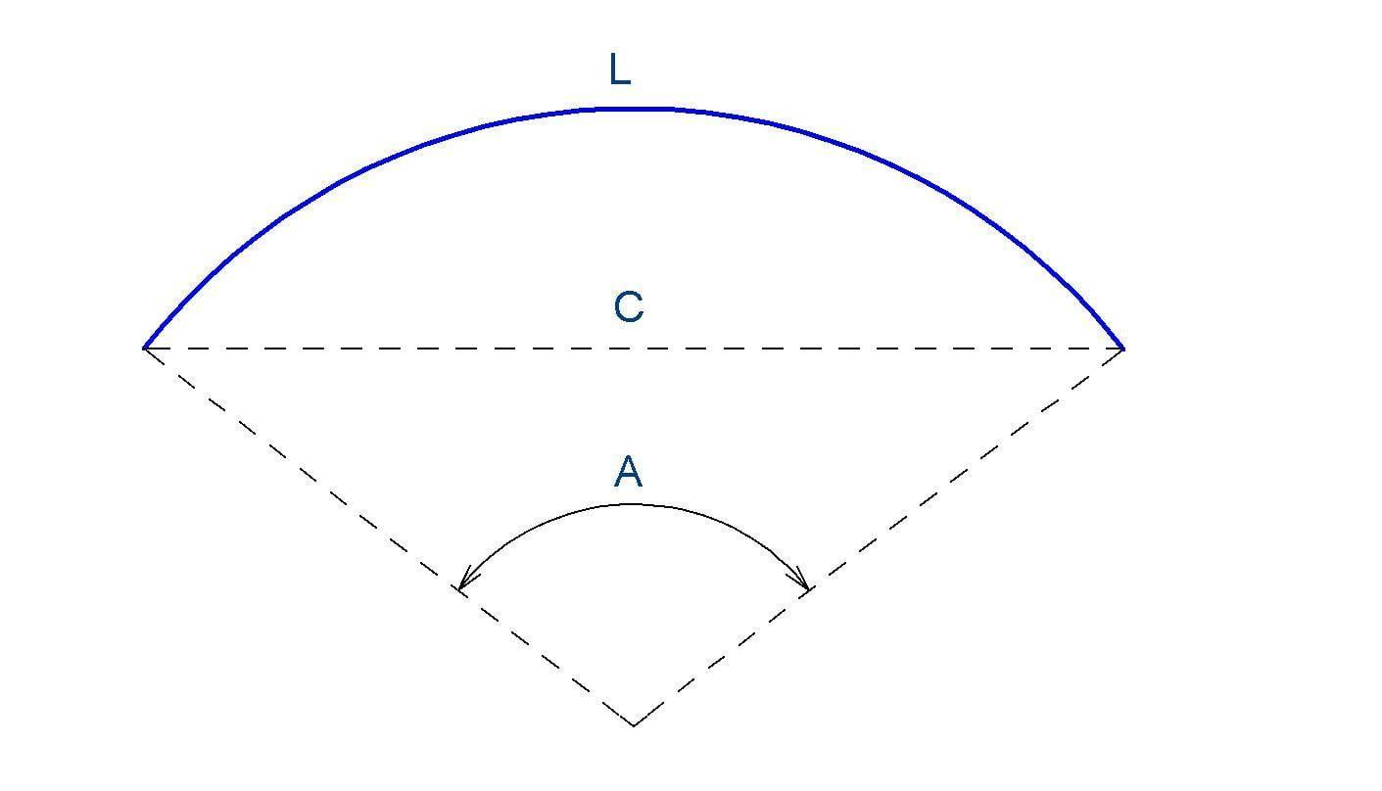
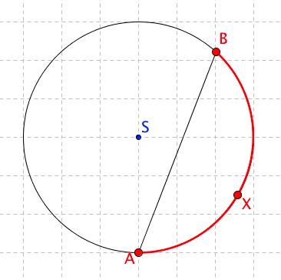
Key points:
- Part of a circle.
- Has two endpoints.
- Has constant radius.
- Does not form a complete closed circle.

2. Open Elliptical Curves
# Source: AI Source: Provided by: [Data Path: Persons Table -> ID Column: 1, Name_En Column: Motasem Essam] -> From: [ChatGPT] on [7/25/2026]
An open elliptical curve is a portion of an ellipse that does not complete the entire ellipse.
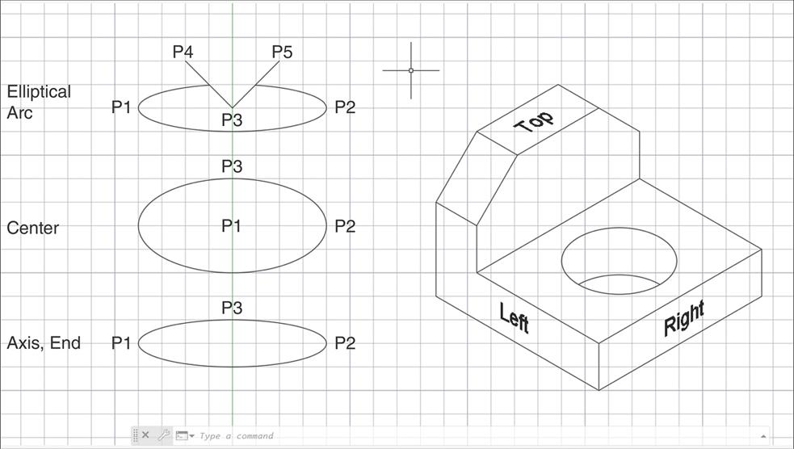
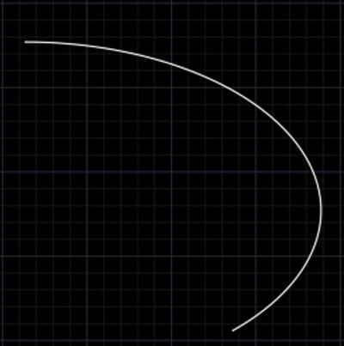
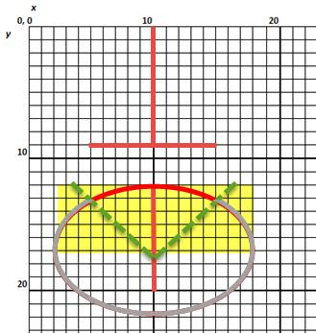
Key points:
- Based on an ellipse.
- Has two endpoints.
- Curvature varies along the curve.
- Does not form a complete closed ellipse.

3. Parabolic Open Curves
# Source: AI Source: Provided by: [Data Path: Persons Table -> ID Column: 1, Name_En Column: Motasem Essam] -> From: [ChatGPT] on [7/25/2026]
A parabolic open curve follows the characteristic shape of a parabola.
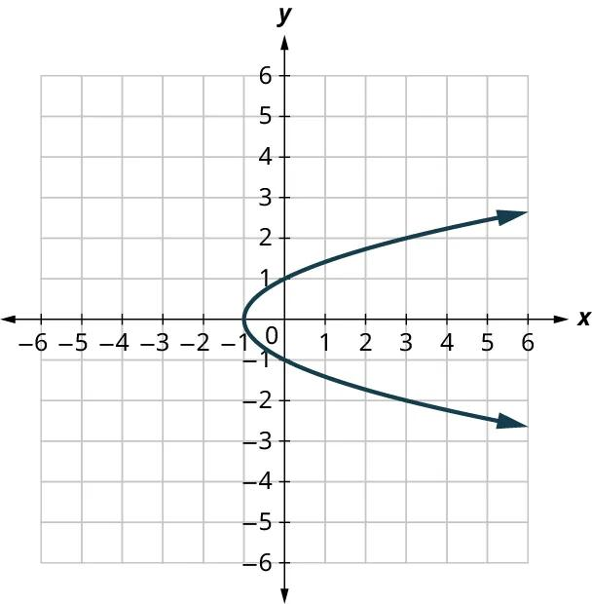
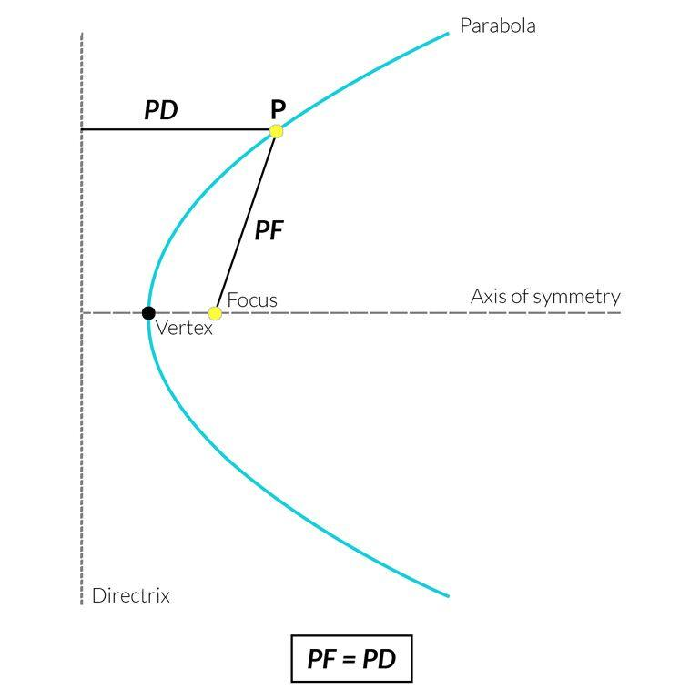
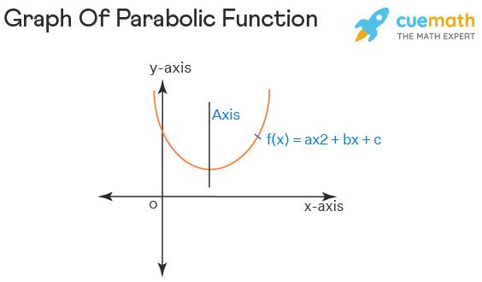
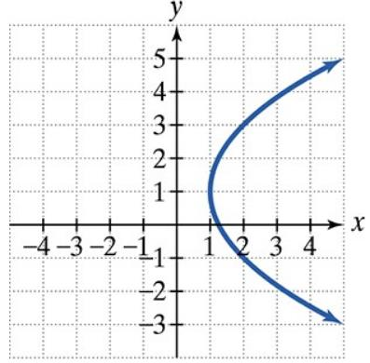
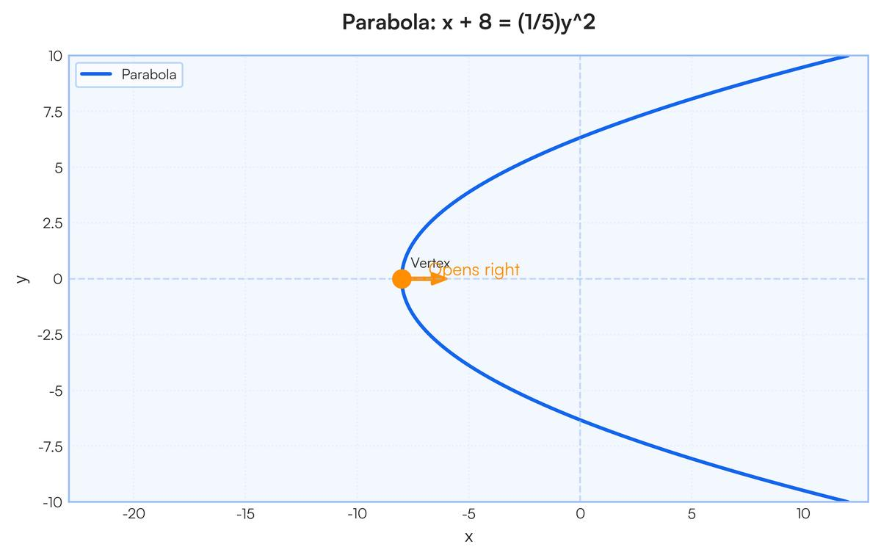
Key points:
- Open by nature.
- Has two directions extending indefinitely.
- Has an axis of symmetry.
- May open upward, downward, left, or right.

4. Hyperbolic Open Curves
# Source: AI Source: Provided by: [Data Path: Persons Table -> ID Column: 1, Name_En Column: Motasem Essam] -> From: [ChatGPT] on [7/25/2026]
A hyperbolic open curve follows one branch or both branches of a hyperbola.
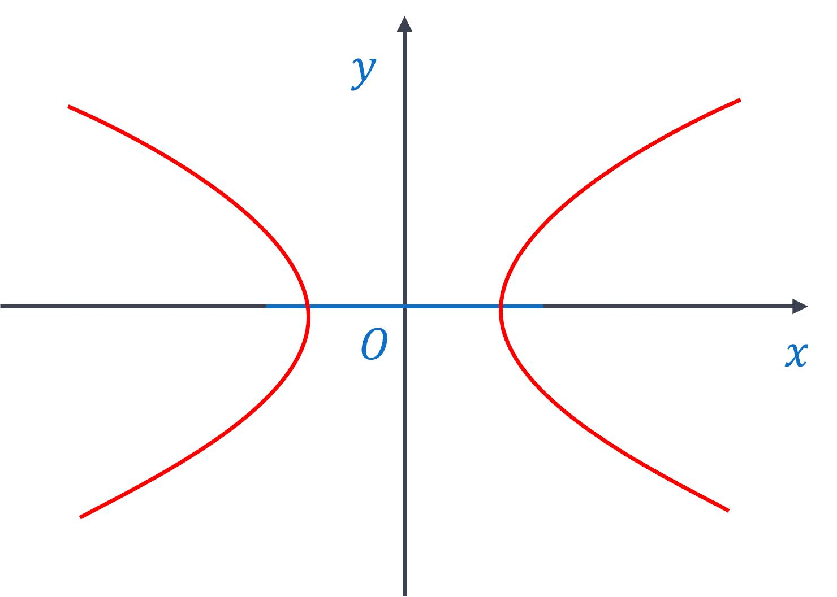
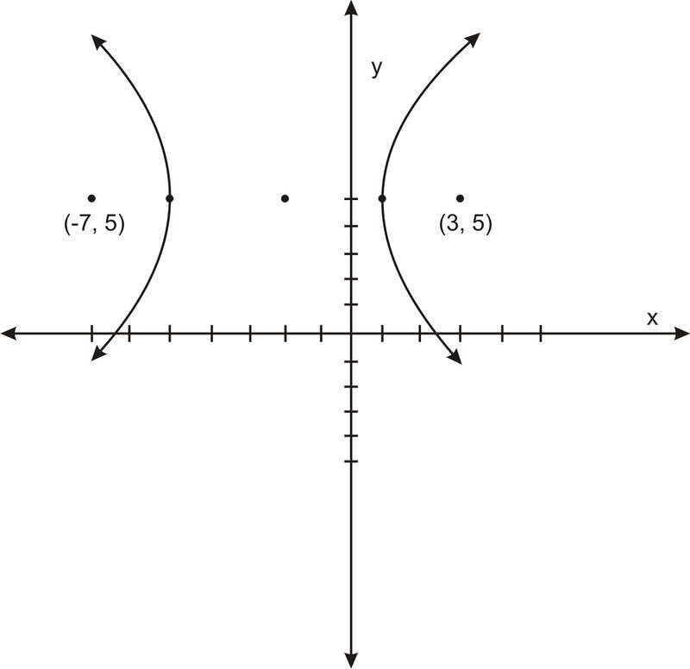
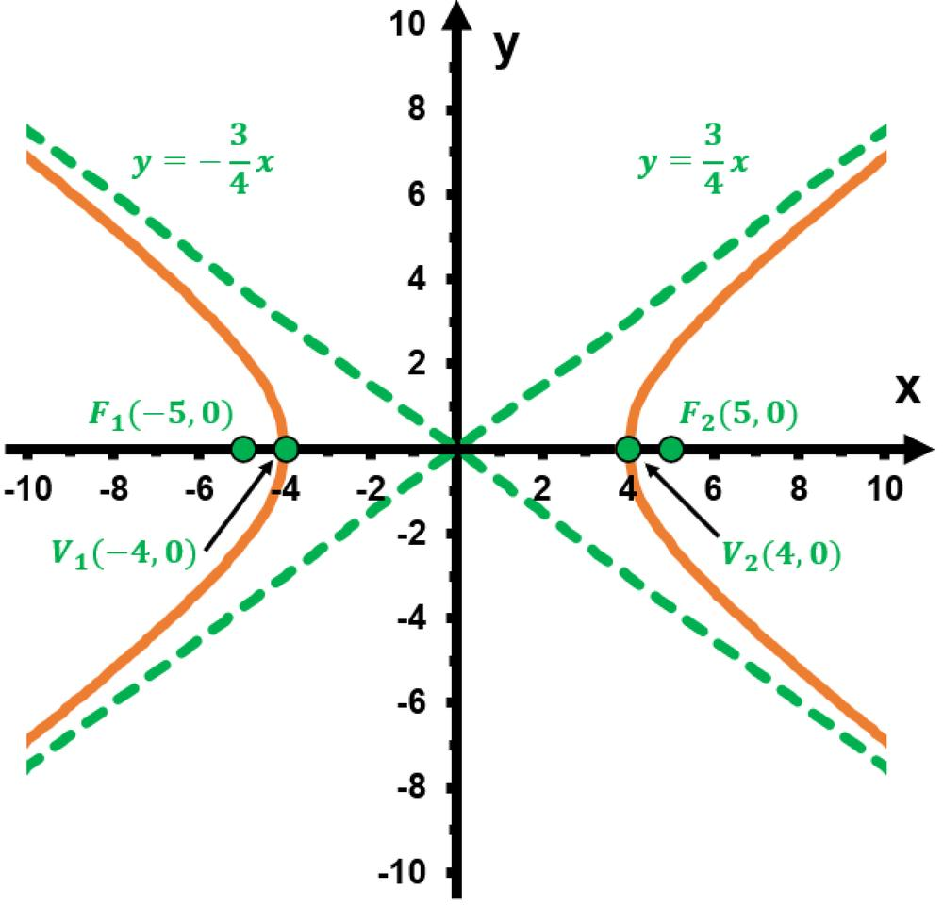
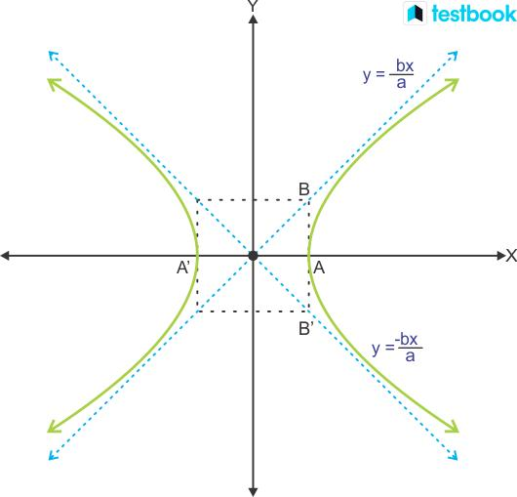
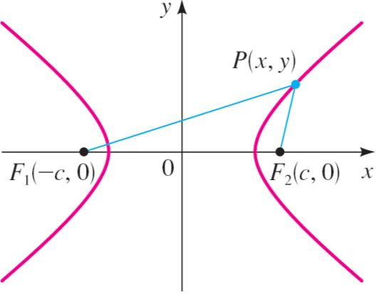
Key points:
- Does not form a closed loop.
- May consist of two separate branches.
- Has characteristic asymptotes.
- Can be symmetric about one or more axes.

5. Wavy Open Curves
# Source: AI Source: Provided by: [Data Path: Persons Table -> ID Column: 1, Name_En Column: Motasem Essam] -> From: [ChatGPT] on [7/25/2026]
A wavy open curve contains repeated or irregular undulations without closing.
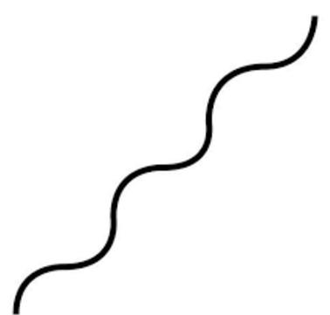
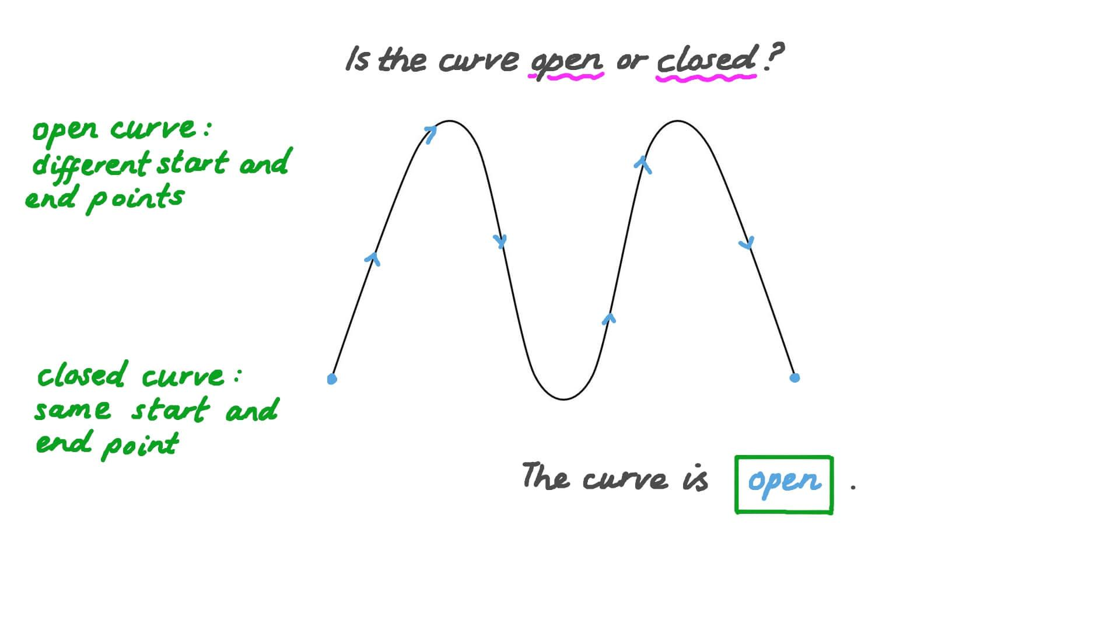
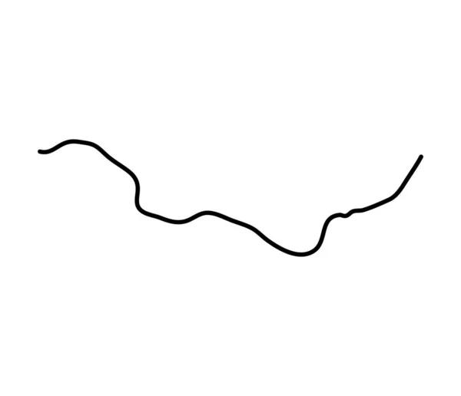
Key points:
- Has two endpoints.
- Contains repeated or irregular waves.
- May be periodic or non-periodic.
- Can be regular or irregular.

6. Spiral-Like Open Curves
# Source: AI Source: Provided by: [Data Path: Persons Table -> ID Column: 1, Name_En Column: Motasem Essam] -> From: [ChatGPT] on [7/25/2026]
A spiral-like open curve winds around a central region without returning to its starting point.
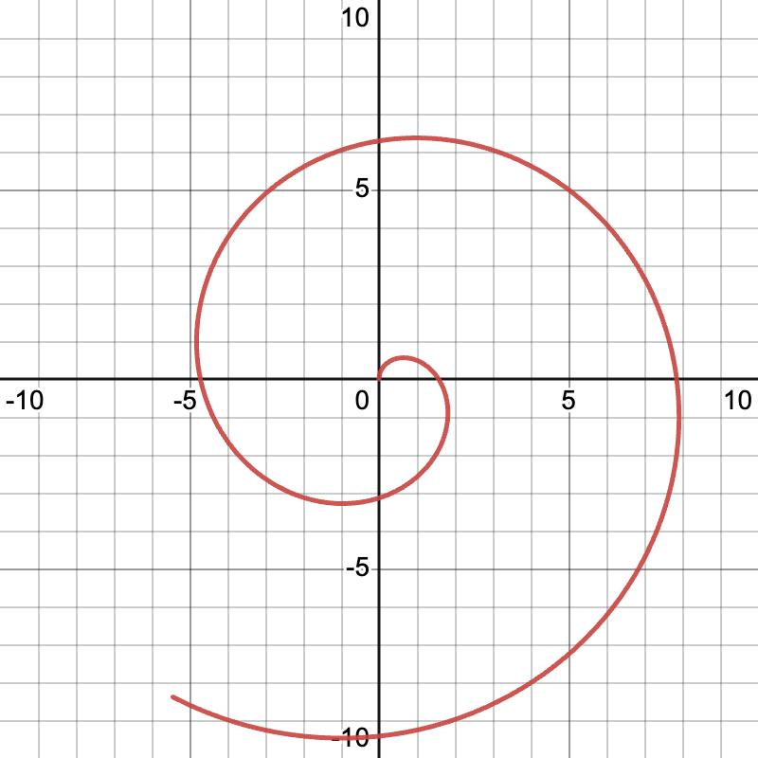
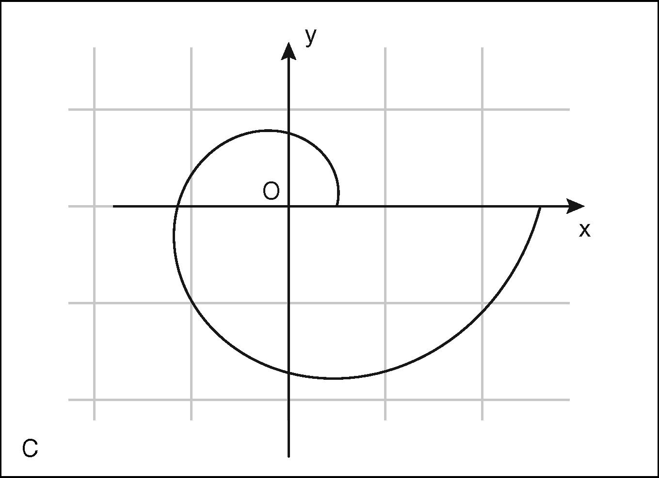
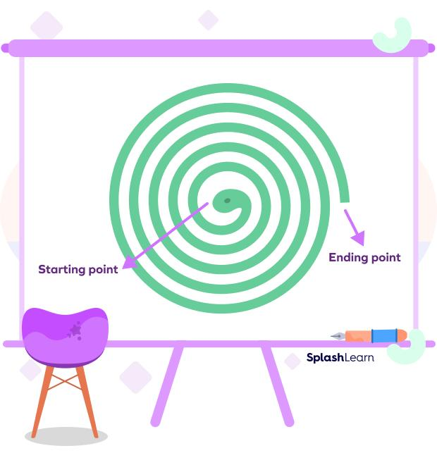
Key points:
- Open.
- Winds around a center or central region.
- Does not completely close.
- May have increasing, decreasing, or variable spacing.

7. Organic Open Curves
# Source: AI Source: Provided by: [Data Path: Persons Table -> ID Column: 1, Name_En Column: Motasem Essam] -> From: [ChatGPT] on [7/25/2026]
An organic open curve is a smooth, natural-looking irregular curve that remains open.
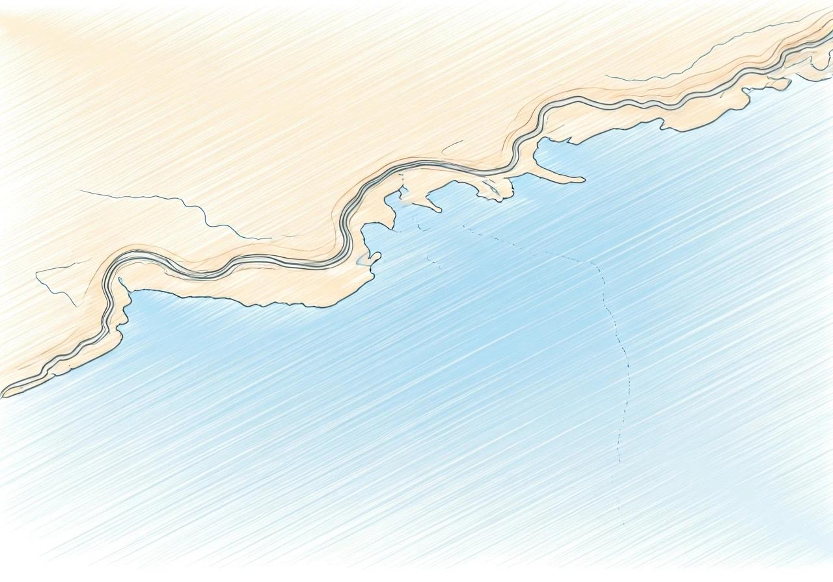

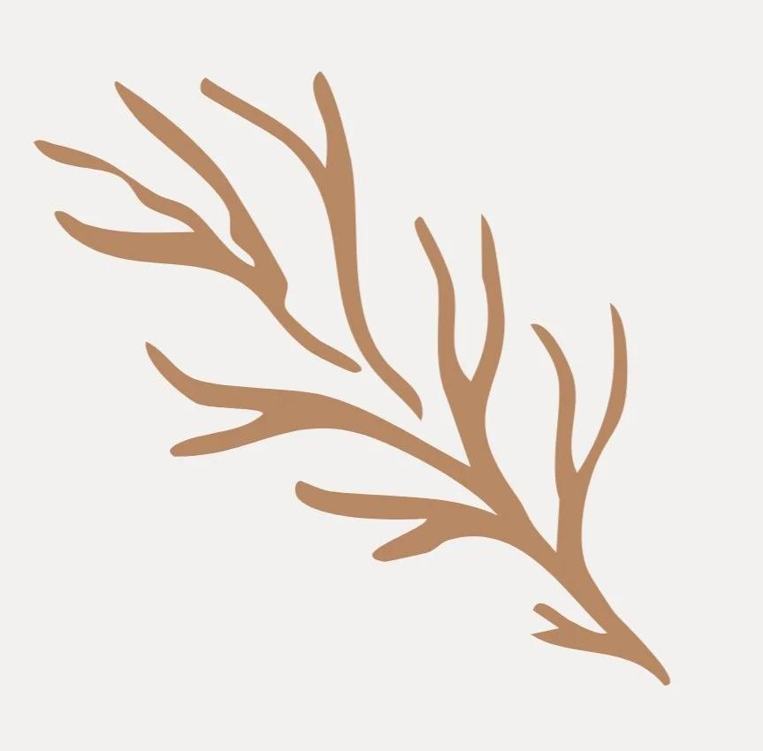
Examples include portions of:
- Branches
- Coastlines
- Leaves
- Natural contours

8. Freeform Open Curves
# Source: AI Source: Provided by: [Data Path: Persons Table -> ID Column: 1, Name_En Column: Motasem Essam] -> From: [ChatGPT] on [7/25/2026]
A freeform open curve is freely designed and does not have to follow a standard geometric equation.
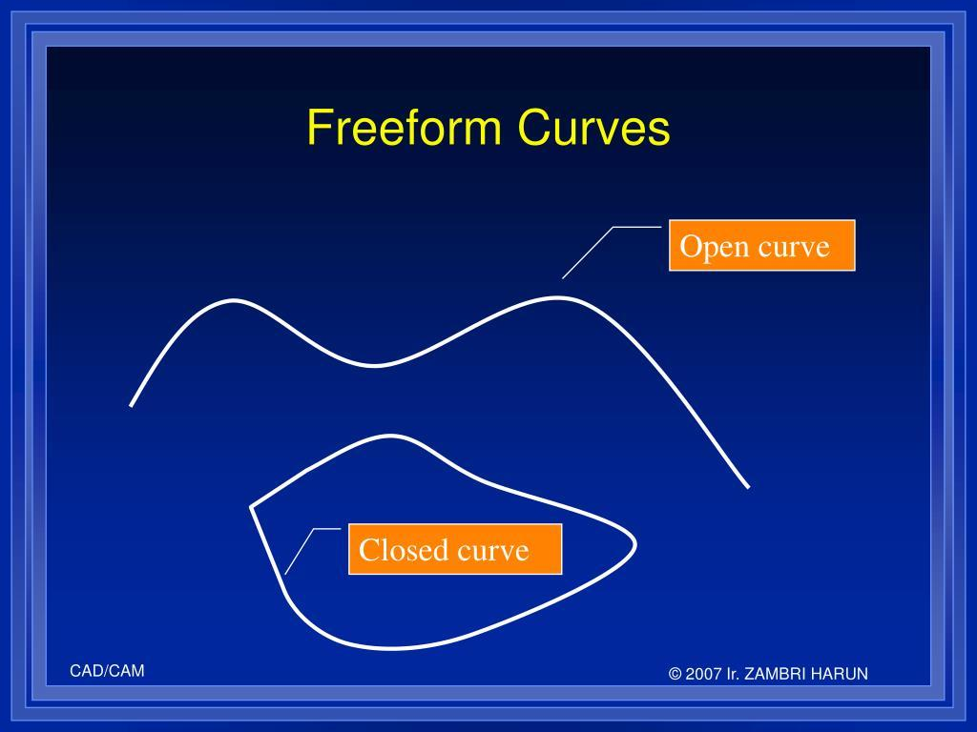
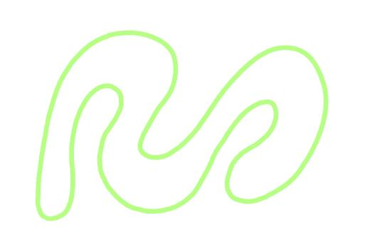
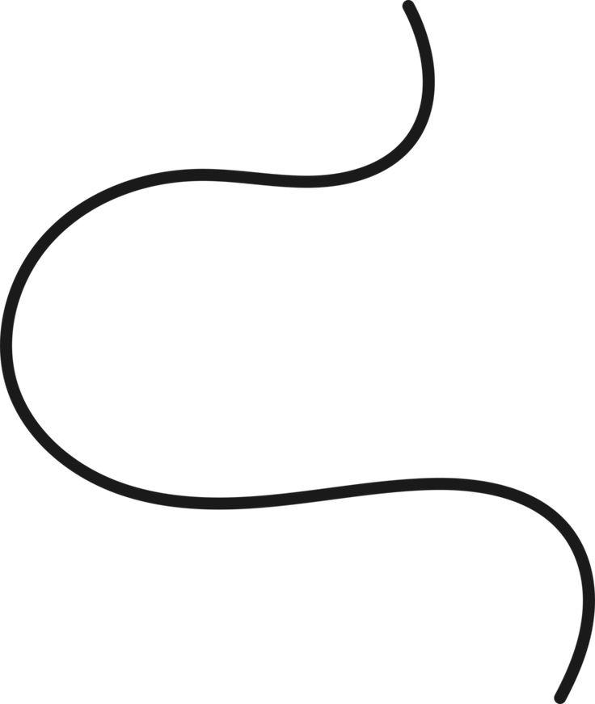
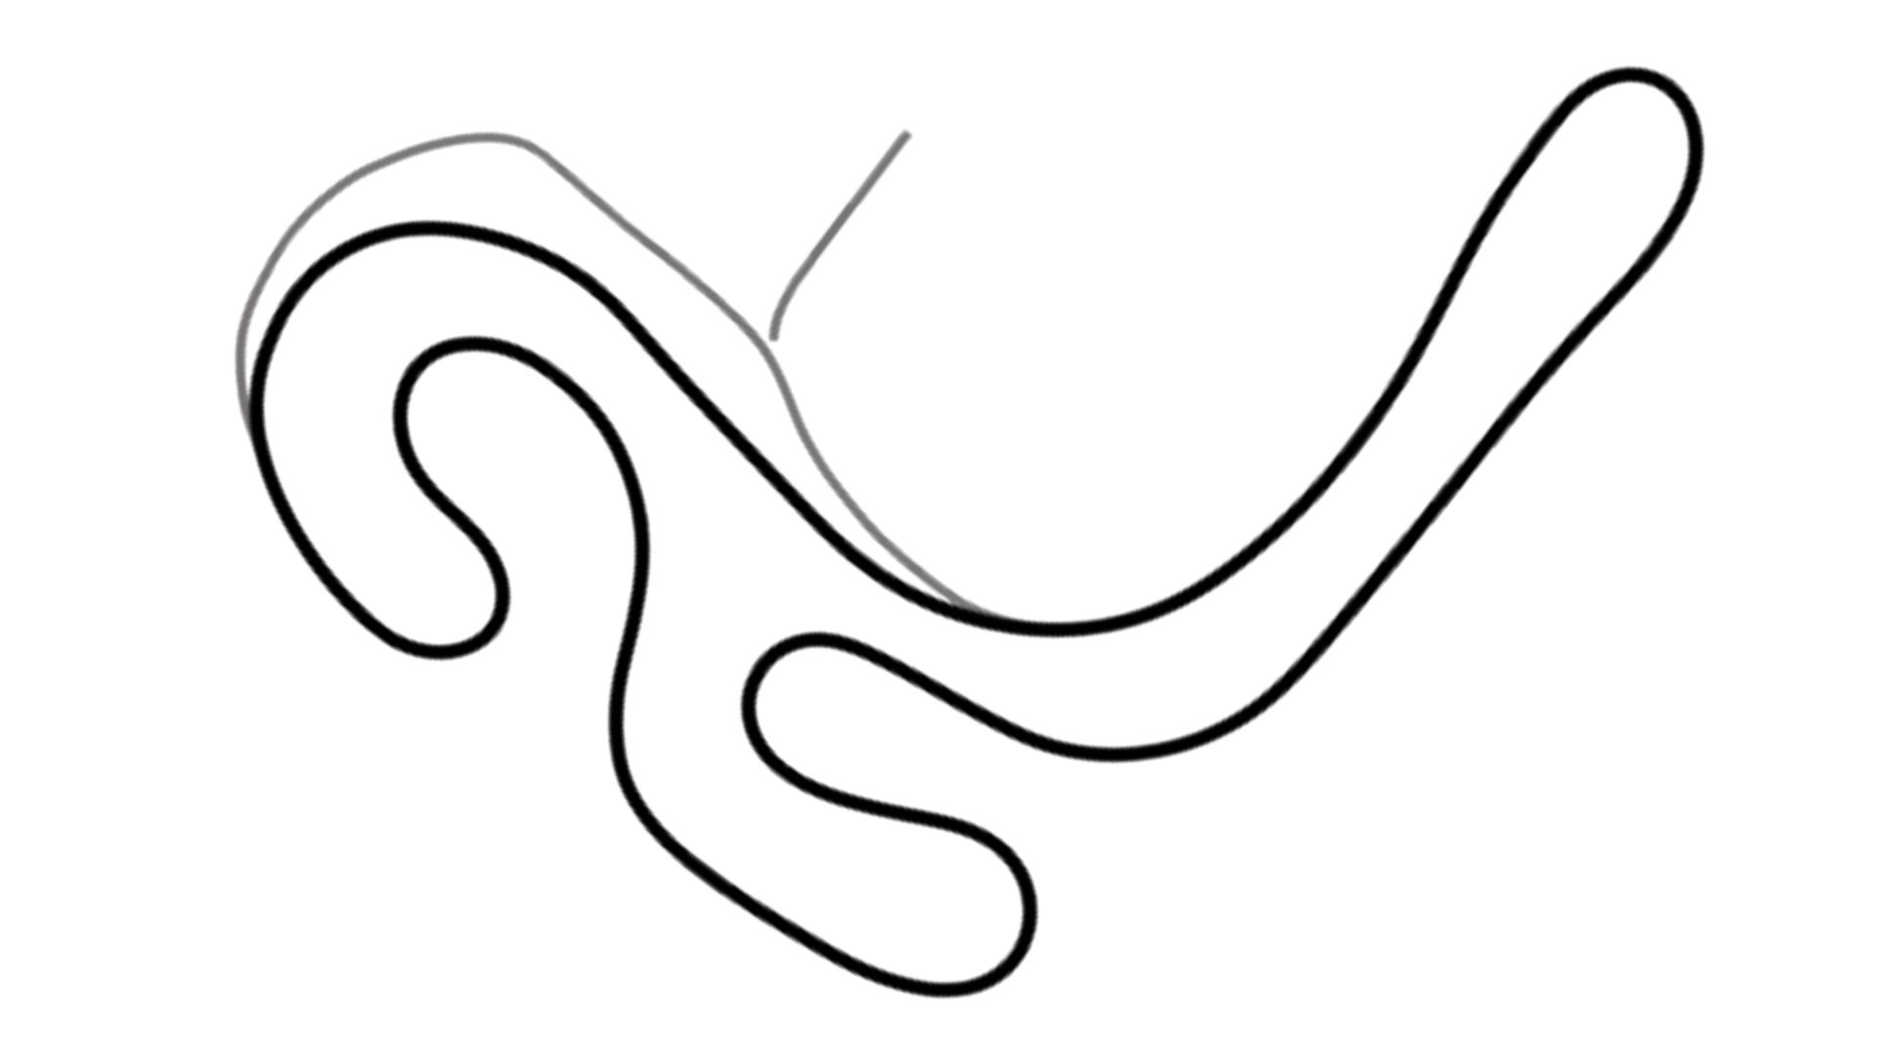
Key points:
- Open.
- Freely constructed.
- No required standard mathematical form.
- May be smooth, irregular, wavy, or artistic.

9. Asymmetric Open Curves
# Source: AI Source: Provided by: [Data Path: Persons Table -> ID Column: 1, Name_En Column: Motasem Essam] -> From: [ChatGPT] on [7/25/2026]
An asymmetric open curve has no recognizable line, reflection, or rotational symmetry.
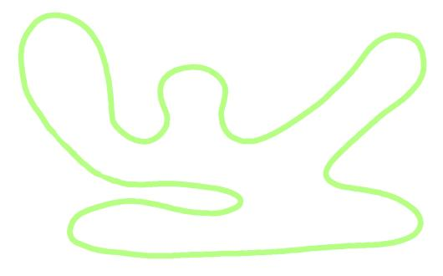
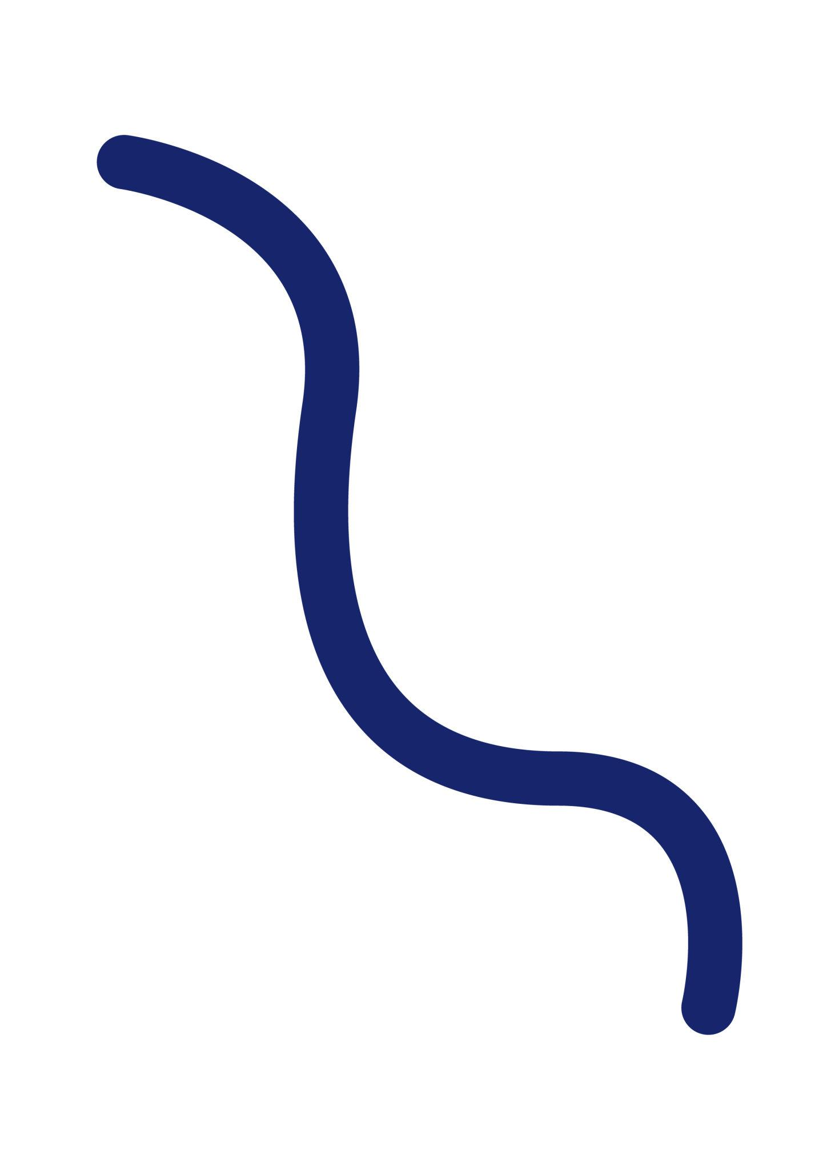
The two sides or portions of the curve do not correspond through a symmetry transformation.

10. Irregular Open Curves
# Source: AI Source: Provided by: [Data Path: Persons Table -> ID Column: 1, Name_En Column: Motasem Essam] -> From: [ChatGPT] on [7/25/2026]
An irregular open curve has changing curvature, direction, or spacing without a regular repeating pattern.
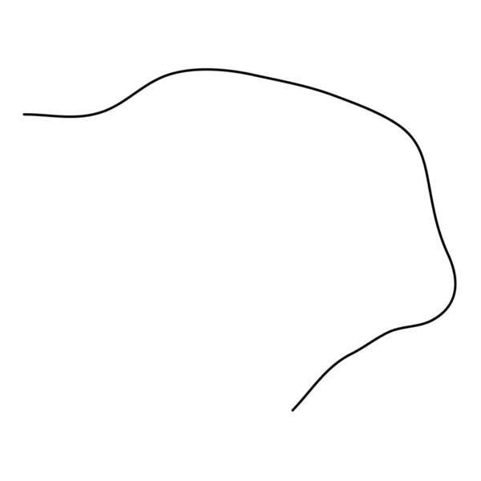
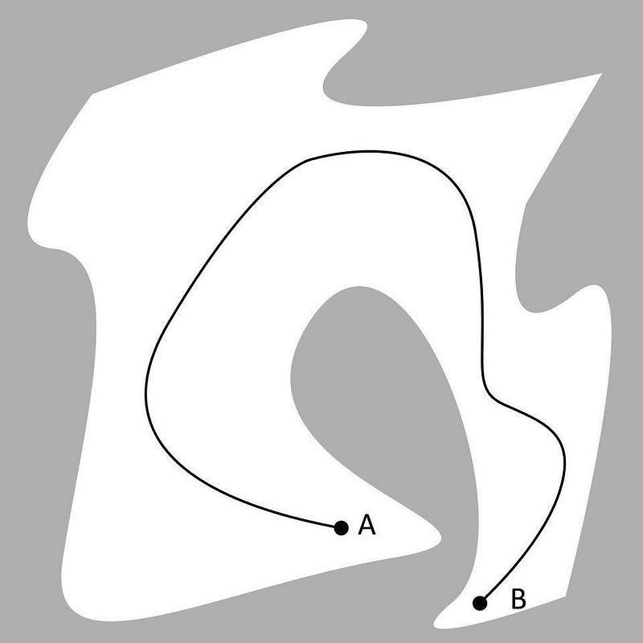
Key points:
- Open.
- No regular repeating structure.
- Curvature can vary significantly.
- May be natural or artificially designed.

11. Smooth Open Curves
# Source: AI Source: Provided by: [Data Path: Persons Table -> ID Column: 1, Name_En Column: Motasem Essam] -> From: [ChatGPT] on [7/25/2026]
A smooth open curve changes direction continuously without sharp corners or abrupt direction changes.
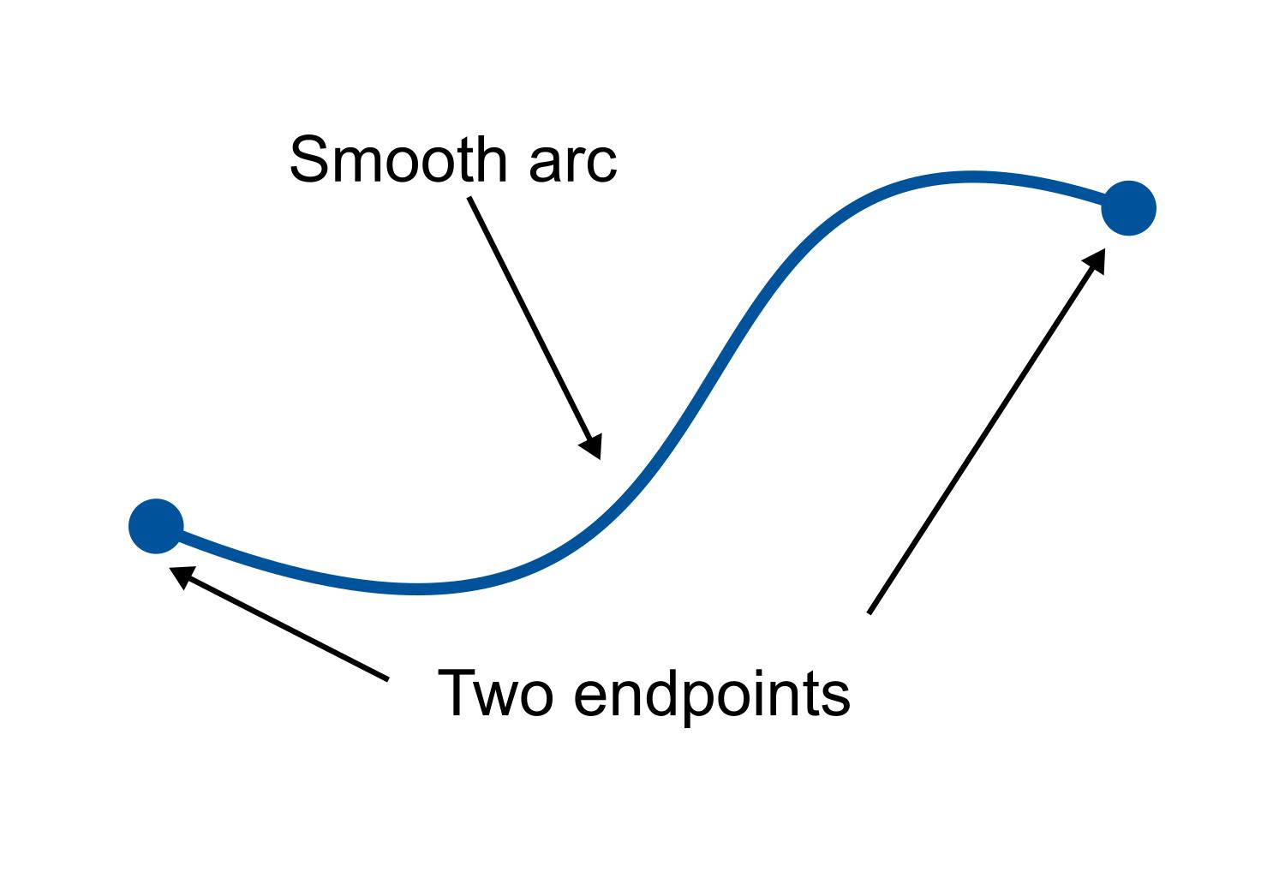
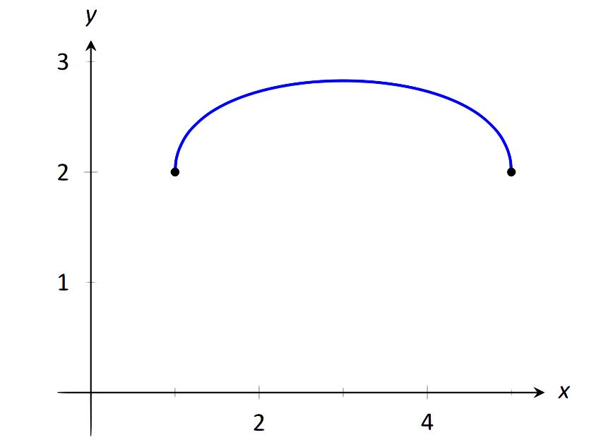
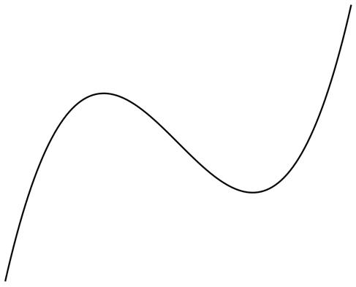

12. Piecewise Open Curves
# Source: AI Source: Provided by: [Data Path: Persons Table -> ID Column: 1, Name_En Column: Motasem Essam] -> From: [ChatGPT] on [7/25/2026]
A piecewise open curve consists of different curve sections joined together.
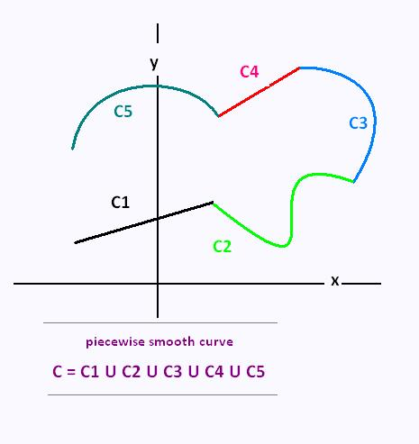
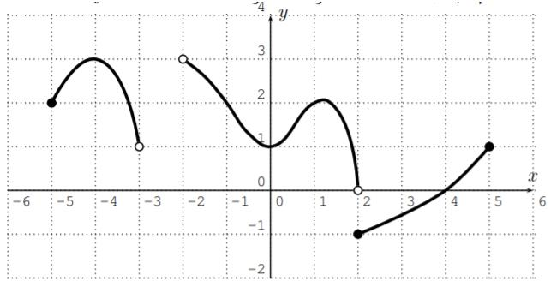
For example, one portion could be circular while another is freeform.

Classification Table
# Source: AI Source: Provided by: [Data Path: Persons Table -> ID Column: 1, Name_En Column: Motasem Essam] -> From: [ChatGPT] on [7/25/2026]
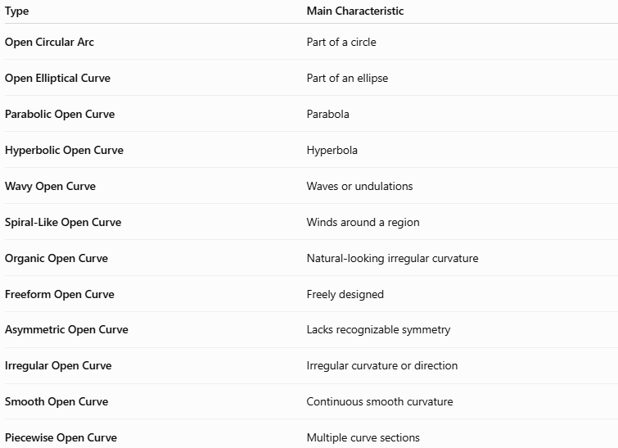
Type | Main Characteristic
Open Circular Arc | Part of a circle
Open Elliptical Curve | Part of an ellipse
Parabolic Open Curve | Parabola
Hyperbolic Open Curve | Hyperbola
Wavy Open Curve | Waves or undulations
Spiral-Like Open Curve | Winds around a region
Organic Open Curve | Natural-looking irregular curvature
Freeform Open Curve | Freely designed
Asymmetric Open Curve | Lacks recognizable symmetry
Irregular Open Curve | Irregular curvature or direction
Smooth Open Curve | Continuous smooth curvature
Piecewise Open Curve | Multiple curve sections

Key Points
# Source: AI Source: Provided by: [Data Path: Persons Table -> ID Column: 1, Name_En Column: Motasem Essam] -> From: [ChatGPT] on [7/25/2026]
An Open Curve:
$$\boxed{\text{Open Curve}=\text{Curved Path}+\text{Two Distinct Endpoints}}$$
It:
- Does not form a closed loop.
- Has two endpoints.
- Can have regular or irregular curvature.
- Can be mathematically defined or freeform.
- Can be symmetric or asymmetric.
- Can consist of one continuous curve or multiple connected curve sections.

Conclusion
# Source: AI Source: Provided by: [Data Path: Persons Table -> ID Column: 1, Name_En Column: Motasem Essam] -> From: [ChatGPT] on [7/25/2026]
Open Curves are curved paths that do not return to their starting point and therefore do not enclose a closed region. They can be classified according to their mathematical form, appearance, symmetry, regularity, and construction.
The main types include open circular arcs, open elliptical curves, parabolic curves, hyperbolic curves, wavy curves, spiral-like curves, organic curves, freeform curves, asymmetric curves, irregular curves, smooth curves, and piecewise curves.

